Who do I call if there is a power cut?

UK Power Networks owns and maintains electricity cables and lines across London, the South East and East of England, making sure your lights stay on.

What causes power cuts?
There are several scenarios that commonly cause power cuts. These include:
- Bad weather when severe winds cause damage to overhead power lines or wind-borne debris and trees fall on power lines pulling them down;
- Water if it gets underground and into the cables; and
- Other people working near overhead lines or digging underground which can occasionally result in damage to our electricity cables.

What we do to mitigate this

We work hard to prevent power cuts. We have an extensive tree-trimming programme to prevent trees from damaging cables. Our flood defence measures are effective at protecting against water damage. We provide plans of where our electricity cables are and we train other companies’ staff to ensure other people do not damage our cables. Overall, each year we spend about £600 million to maintain and replace power lines ensuring that the electricity network remains reliable.

Unfortunately, despite our efforts, accidents happen. If you experience a loss of power supply, you can contact us in the following ways:

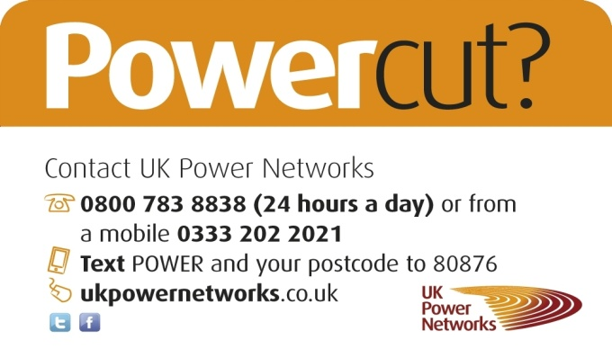

Vulnerable customers

During a power cut we understand that some people may need extra support and offer priority assistance for our vulnerable customers.

If we know where you are, we can help. We hold a list – called Priority Services Register – of thousands of customers who would feel particularly vulnerable during a power cut and we provide them with extra support if needed.

Who can apply?

Customers who are dependent on medical equipment; customers who are chronically sick or have a disability; customers who are blind, visually impaired or deaf; customers with young babies; nursing or residential homes and elderly customers.

We will consider other cases too if you think you would feel particularly vulnerable during a power cut.

What we can do

We can’t get your power back on more quickly (although we will try our hardest) but we can:
- Call you pro-actively if we expect bad weather in your area that could result in a power cut and offer useful advice on how to prepare
- Offer you a special priority phone number that you can call if you have a power cut
- Provide with a generator where necessary or book you into a hotel
- Keep you updated during a power cut, either by sending you text messages or calling you
- With your agreement, we can ask the British Red Cross to visit your home for extra help and support

How to apply
Please help us spread the word about the Priority Service Register so we can reach more people who need us in power cuts.

If you or someone you know, meets our criteria above and lives in London, the South East of England or the East of England then please apply by either:
- Emailing psr@ukpowernetworks.co.uk
- Writing to Customer Relations team, UK Power Networks, Fore Hamlet, Ipswich, IP3 8AA
- Applying online here: www.ukpowernetworks.co.uk/priority

